
CANOE
Onboarding Guide
Canadian Open Energy Model

A sequenced resource guide for new students and researchers joining the CANOE modelling team.

How to Use This Guide
This guide provides a sequenced pathway through the resources required to understand, install, and use the CANOE energy system model. Resources are organized into five stages with explicit dependencies between them.

What this guide covers
- Environment setup: software and solvers
- Conceptual framing: what CANOE and TEMOA (Tools for Energy Model Optimization and Analysis) are and how they relate
- Installation and data infrastructure
- Model understanding via the official workshop video series
- Hands-on practice via the onboarding activity series and repository
- Ecosystem awareness: the full suite of related repositories

What this guide does not cover
- Linear programming theory if you want mathematical depth, see the optional Boyd reference in Stage 1
- SQL beyond basic commands used to design scenarios and analyze data
- Python programming fundamentals; basic Python literacy is assumed
- Sector-specific data details (see the CANOE documentation once you are operational)

CANOE YouTube Channel
- Several components in the onboarding guide make use of two YouTube series
- The first YouTube series covers installation, SQL commands, output visualization and 5 workshop activities
- The second YouTube series cover an updated version but includes less details on installation and SQL commands but covers additions usage of tools such as the interface, representative periods module, and modelling philosophy when approaching scenario and research paper design
Section 1 | Environment Setup

1.1 Core Software
These are some of the core and recommended software dependencies that are used to run CANOE. The installation of each of these are covered in the first YouTube video “How to download and install Temoa for the CANOE model” listed in Section 2.

Resource | Link / Description | Required?
Python or Anaconda | https://www.anaconda.com/download  Provides Python + conda package manager. Use Anaconda or .venv for package control; do not use both simultaneously | Yes
VS Code | https://code.visualstudio.com  Primary code editor. Install the Python extension after setup. | Recommended
Git | https://git-scm.com/downloads  Version control. Required to clone all CANOE repositories using the command line interface. | Yes
DBeaver or DB Browser for SQLite | https://dbeaver.io/download/  https://sqlitebrowser.org  Database inspection tool. You will use this to inspect CANOE's SQLite input/output files. Either tool works — DBeaver has more features, DB Browser is simpler. | Yes
PowerBI Desktop | https://powerbi.microsoft.com/desktop  Used to examine CANOE model outputs. Covered in the onboarding video series. | Recommended

1.2 Gurobi Solver
It is recommended to use Gurobi as the default optimization solver. You must obtain an academic named-user license. This is free for university students and researchers but requires registration with your institutional email.

- Go to the Gurobi Academic License page: https://www.gurobi.com/academics
- Register using your university email address and request a Named-User Academic License.
- Follow the Gurobi instructions to install the license on your machine (grbgetkey command).
- Verify the license is active by running: gurobi_cl --version in your terminal.

Note: The license is tied to your machine. If you change computers, you must re-register. Do not attempt to run CANOE without an active Gurobi license — the model will fail at the solver step with a cryptic error.

Section 2 | Conceptual Framing
Before installing anything, read the following documentation to understand what CANOE is, what TEMOA is, and how they relate.

2.1 CANOE Documentation
Start with the CANOE home page and read through the overview sections. This documentation includes what sectors CANOE covers, how the dataset is structured, and what the Quickstart workflow looks like at a high level. The Quickstart steps are covered in Section 2 of this document.

Resource | Link / Description | Required?
CANOE Documentation | https://canoe-main.github.io/CANOE/  Read: What is CANOE, What can it do, Getting Started overview | Yes
CANOE QuickStart | https://canoe-main.github.io/CANOE/quickstart/  Read for context only at this stage — do not execute steps yet | Yes
CANOE Data Guide | https://canoe-main.github.io/CANOE/data_guide/  Skim the sector overview; Useful to understand how specific sector data is organized. | Skim

2.2 TEMOA Documentation
CANOE is built on the TEMOA (Tools for Energy Model Optimization and Analysis) framework. Understanding TEMOA's structure and how it uses SQLite databases to store model inputs and outputs is essential before you touch any data files.

Resource | Link / Description | Required?
TEMOA Project Docs | https://docs.temoaproject.org/en/latest/  Primary TEMOA reference. Read the Preface and the schema/variable sections. This is where all table names and parameter definitions are documented. | Recommended
Temoa Project GitHub | https://github.com/TemoaProject/temoa  Reference only — you will clone the CANOE fork, not this upstream repo. Useful for understanding the broader project context and the Utopia example database. | Reference

2.3 Optional Mathematical Background
CANOE solves a linear program (LP) / mixed-integer linear program (MILP). You do not need to understand the mathematics to run the model or conduct scenario analysis. However, if you intend to modify the model structure, extend it, or interpret solver behaviour, mathematical background will become important.

- Stephen Boyd & Lieven Vandenberghe, Convex Optimization (free PDF: https://web.stanford.edu/~boyd/cvxbook/) — the standard reference. Chapters 1-4 and Chapter 11 are most relevant.
Section 3 | Installation and Data Infrastructure
With conceptual background in place, work through installation. Follow the videos in the order listed. The CANOE Getting Started README documentation runs in parallel with these videos and is useful to have it open as a reference.

3.1 Install TEMOA for CANOE
Resource | Link / Description | Required?
Video: Install TEMOA | CANOE Onboarding Playlist, Video 12 (11:25)  How to download and install TEMOA for the CANOE model. Clone the CANOE-main/temoa repo, 1.0.0-dev-operator branch. | Yes
CANOE-main/temoa | https://github.com/CANOE-main/temoa  Clone this repo — not the upstream TemoaProject repo. Use the 1.0.0-dev-operator branch. | Yes

Note: After installation, verify TEMOA runs on the included example database before proceeding. If Gurobi is not found at this step, resolve the license issue before continuing or use the free APPSI HiGHS solver.

3.2 SQLite and Database Inspection
Resource | Link / Description | Required?
Video: SQLite for CANOE | CANOE Onboarding Playlist, Video 11 (4:36)  Covers how to manipulate SQLite files for use in CANOE. Open DBeaver or DB Browser alongside this video. | Yes
CANOE Dataset (Zenodo) | https://zenodo.org/records/18435395  Download the CANOE national dataset. This is the primary input database you will filter and use. | Yes

3.3 Data Filtering and Temporal Resolution
The CANOE national dataset is large. Before running the model, you must filter it to your region of interest and set temporal resolution. Two tools handle this. This is covered in Section 3, workshop 6.

Resource | Link / Description | Required?
canoe_interface | https://github.com/CANOE-main/canoe_interface  Filters the national dataset by sector, region, and scenario. Download the executable from the Releases section (no need to clone unless you intend to modify it). | Yes
representative_periods | https://github.com/CANOE-main/representative_periods  Adds temporal resolution data to your filtered database. Run this after canoe_interface. | Yes

General workflow:

- Download the CANOE dataset from Zenodo
- Run canoe_interface to filter by region and sector
- Run representative_periods to configure temporal resolution
- Run TEMOA on the resulting filtered database

3.4 Interpreting Periods & Vintages in CANOE
CANOE organizes time into five-year optimization periods, where each period label denotes the start of the interval (e.g., the 2025 period spans December 31, 2025 – December 31, 2030). All techno-economic inputs assigned to a period — costs, efficiencies, emissions factors, constraints — reflect projections for the end of that interval. This is the forward-facing convention: the label looks forward to when the technology is operating, not backward to when it was built.
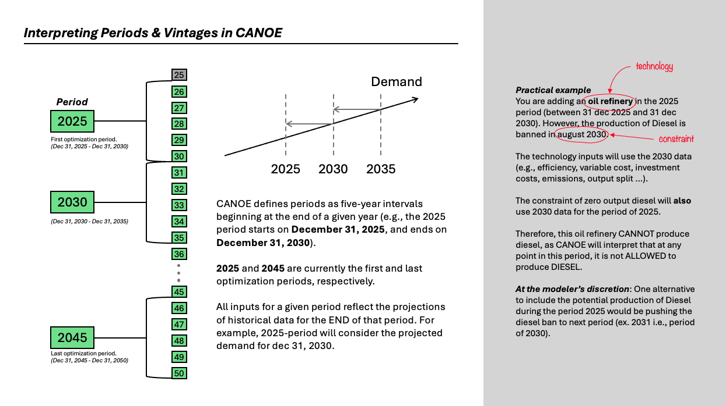

NOTE: Database–config dependency (read carefully): Two databases exist in circulation. The legacy Zenodo database uses a backward-facing convention (period label = end of interval), which requires the terminal period 2050 to be uncommented in config.yaml to close the final interval correctly within the representative-periods module. The updated database is forward-facing and requires 2050 to remain commented out. Swapping databases without updating this config flag will throw an error when checking if SegFrac sums to 1 before the model is able to begin solving.
Section 4 | Model Understanding — Workshop Series
Watch the six workshop videos in order. These cover scenario design, data structure, visualization, and the model interface in depth.

Have VS Code, DBeaver/DB Browser, and your installed CANOE environment open while watching. Apply concepts directly to your installation as you go.

4.1 Workshop Activity Series
Resource | Link / Description | Required?
Workshop 1 | Introduction and Practice Scenario Design (2:12:31)  The most important video in this series. Covers the full model workflow end-to-end. | Yes
Workshop 2 | Scenario Design (54:55)  Deeper coverage of how scenarios are structured and parameterised in the SQLite database. | Yes
Workshop 3.1 | Data Visualization (55:45)  Output analysis and visualization approaches. | Yes
Workshop 3.2 | PowerBI for CANOE Outputs, Video 10 (6:57)  How to use PowerBI Desktop to examine and visualize CANOE model outputs. Complete this before the activity series. | Yes
Workshop 4 | New Features in CANOE 3.1 (56:38)  Model updates and new capabilities. Important for understanding the current version. | Yes
Workshop 5 | Code Walkthrough (34:30)  Walks through the TEMOA codebase. Useful for understanding what the model is doing when it runs. | Yes
Workshop 6 | CANOE Interface Showcase (25:52)  Demonstrates the canoe_interface and representative periods tool in detail. | Yes

4.2 Onboarding Activity Series
Resource | Link / Description | Required?
Activity 1: Breakdown | CANOE onboarding activity 1 breakdown  Watch first. Explains Activity 1 | Yes
Activity 1: Walkthrough | CANOE onboarding activity 1 walkthrough  Watch after attempting Activity 1 yourself. | Yes
Activity 2: Breakdown and walkthrough | CANOE onboarding activity 2 breakdown and walkthrough  Watch first. Explains Activity 2. | Yes
Activity 3: Breakdown | CANOE onboarding activity 3 breakdown  Watch first. Explains Activity 3. | Yes
Activity 3: Walkthrough | CANOE onboarding activity 3 walkthrough  Watch after attempting Activity 3 yourself. | Yes
Activity 4: Breakdown | CANOE onboarding activity 4 breakdown  Watch first. Explains Activity 4. | Yes
Activity 4: Walkthrough | CANOE onboarding activity 4 walkthrough  Watch after attempting Activity 4 yourself. | Yes
Activity 5: Breakdown | CANOE onboarding activity 5 breakdown  Watch first. Explains Activity 5. | Yes
Activity 5: Walkthrough | CANOE onboarding activity 5 walkthrough  Watch after attempting Activity 5 yourself. | Yes

4.3 Onboarding Repository
The onboarding repository contains practice scenarios for hands-on SQL-based scenario editing. Work through it alongside and after the activity video series.

Resource | Link / Description | Required?
CANOE Onboarding Repo | https://github.com/CANOE-main/Onboarding  Hands-on practice material. SQL-based scenario editing exercises. Clone this repo and work through the included exercises. | Recommended

Section 5 | The CANOE Repositories
After completing Stages 0-4 you are operational with CANOE. This stage documents the broader repository ecosystem.

5.1 Repository Ecosystem
The CANOE project consists of the following repositories. The ones marked Core are used in everyday modelling. The sector repos and utilities are used when working with specific data.

Resource | Link / Description | Required?
CANOE-main/temoa | https://github.com/CANOE-main/temoa  Core modelling framework. You cloned this in Stage 2. | Core
canoe_interface | https://github.com/CANOE-main/canoe_interface  Data filtering interface. Used in Section 2. | Core
representative_periods | https://github.com/CANOE-main/representative_periods  Temporal resolution configuration. Used in Section 2. | Core
Onboarding | https://github.com/CANOE-main/Onboarding  Practice scenarios. Used in Section 4. | Core
CANOE_SWAP | https://github.com/CANOE-main/CANOE_SWAP  Utility script for swapping data between databases. | Utility
pyam-dashboard | https://github.com/CANOE-main/pyam-dashboard  Preliminary results dashboard using pyam. | Utility
canoe-pair-programmer | https://github.com/CANOE-main/canoe-pair-programmer  AI assistant for CANOE code and data extraction questions. Also available as a Docker image. Useful when debugging model behaviour. | Utility
canoe-electricity | https://github.com/CANOE-main/canoe-electricity  Electricity sector data processing and input generation. | Sector
canoe-transportation | https://github.com/CANOE-main/canoe-transportation  Transportation sector data and processing scripts. | Sector
canoe-industry | https://github.com/CANOE-main/canoe-industry  Industry sector data processing. | Sector
canoe-residential | https://github.com/CANOE-main/canoe-residential  Residential sector data processing. | Sector
canoe-commercial | https://github.com/CANOE-main/canoe-commercial  Commercial sector data processing. | Sector
canoe-fuels | https://github.com/CANOE-main/canoe-fuels  Fuels sector data processing. | Sector
canoe-agriculture | https://github.com/CANOE-main/canoe-agriculture  Agriculture sector data processing. | Sector
canoe-dataset-merge | https://github.com/CANOE-main/canoe-dataset-merge  Aggregates all sector databases into a single national model input. | Utility

Questions? Use the canoe_help_desk channel in Slack or use the canoe-pair-programmer AI assistant for code and data questions: https://github.com/CANOE-main/canoe-pair-programmer

